|  |  |  |
| --- | --- | --- |
|  | **JSPM’s**  **RAJARSHI SHAHU COLLEGE OF ENGINEERING**  **TATHAWADE, PUNE-33**  **(An Autonomous Institute Affiliated to SavitribaiPhule Pune University,Pune)** |  |

**Department of Information Technology**

**Innovation by Faculties in Teaching Learning**

**Name of the Course:** Advance Software Modeling

**Name of the Faculty:** Prof. R.T.Umbare

**Name of the Innovative Method used:** Virtual Lab

**Name of the topic:** **Modeling UML Use Case Diagrams and Capturing Use Case Scenarios**

**Statement of Clear Goa**l: The goal of the virtual lab is to provide a clear, interactive, and practical platform for learning UML Use Case Diagram modeling and capturing Use Case Scenarios. Through the lab, learners will gain hands-on experience in identifying system actors, defining use cases, and visualizing system functionalities from the user's perspective. The objective is to enable students and professionals to effectively model software requirements and document user interactions, strengthening their foundation in software design and analysis.

**Significance of result:** Modeling UML Use Case Diagrams and capturing Use Case Scenarios is essential for understanding how users interact with a system and for defining functional requirements early in the development process. Use Case Diagrams offer a high-level visual representation of system behavior, helping teams align their understanding of user goals. Capturing detailed Use Case Scenarios further enriches this process by documenting step-by-step interactions, edge cases, and alternative flows. In a virtual lab setting, these practices help bridge theory with application, enabling learners to simulate realistic project scenarios, improve requirement clarity, and support better software planning and development.

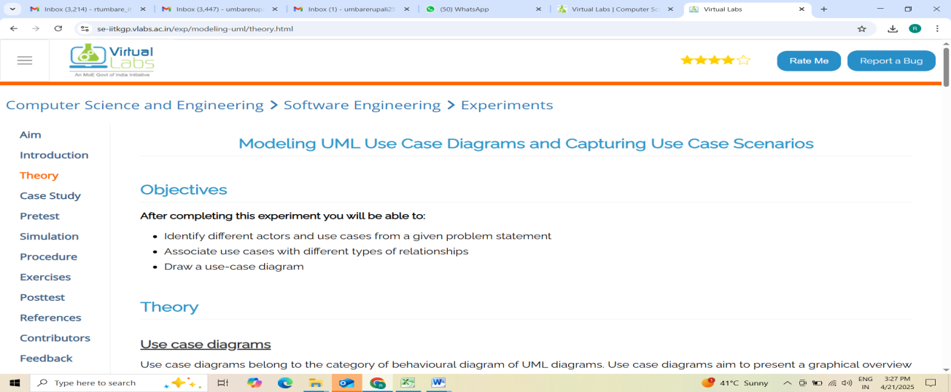

**Name of the Course:** Advance Software Modeling

**Name of the Faculty:** Prof. R.T.Umbare

**Name of the Innovative Method used:** Virtual Lab

## Name of the topic: Statechart and Activity Modeling

**Statement of Clear Goal:** The goal of the **virtual lab** is to provide a comprehensive and easy-to-understand environment for learning **Statechart and Activity Modeling**. Through the lab, users will explore the fundamental concepts of behavioral modeling, including the creation and interpretation of statecharts and activity diagrams. The objective is to create a practical and interactive space where learners can simulate and visualize system behaviors, enhancing their understanding and ability to apply these modeling techniques in both academic coursework and real-world system design.

**Significance of result:** The implementation of Statechart and Activity Modeling within a virtual lab setting offers a powerful means of understanding how complex systems behave and interact over time. Statecharts model the dynamic behavior of systems by representing different states and transitions triggered by events, helping learners grasp the logic behind system responses. Activity diagrams complement this by illustrating workflows, decisions, and concurrent processes. Together, they promote structured thinking and provide a visual foundation for designing, analyzing, and improving software systems, ensuring clarity and precision in both analysis and implementation.

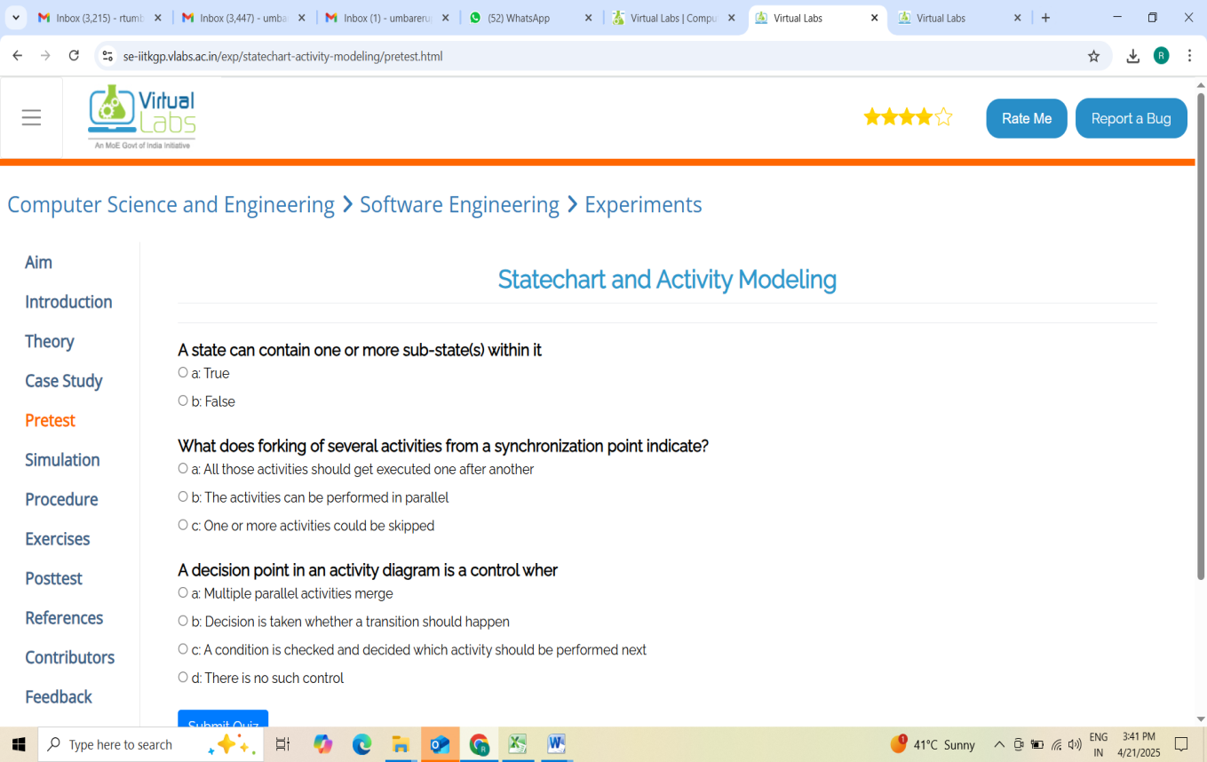

**Name of the Course:** Advance Software Modeling

**Name of the Faculty:** Prof. R.T.Umbare

**Name of the Innovative Method used:** Virtual Lab

## Name of the topic: Modeling UML Class Diagrams and Sequence Diagrams

**Statement of Clear Goal:** The goal of the **virtual lab** is to offer an engaging and interactive environment for learning and practicing **UML Class Diagrams and Sequence Diagrams**. Through guided exercises and simulations, the lab helps learners understand how to model the static structure of a system using class diagrams, and how objects interact over time using sequence diagrams. The objective is to strengthen users' ability to analyze and design object-oriented systems by visualizing both structure and behavior in a practical, hands-on manner.

**Significance of result:** The use of **UML Class Diagrams and Sequence Diagrams** is fundamental in object-oriented design, helping developers and analysts represent and understand both the architecture and the interactions within a system. Class diagrams define the system's classes, attributes, methods, and relationships, providing a blueprint for implementation. Sequence diagrams illustrate how objects communicate in a time-ordered sequence, revealing the flow of control and the logic of operations. By exploring these tools in a virtual lab, learners gain essential skills in modeling complex software systems, improving their ability to design robust, maintainable, and well-structured applications

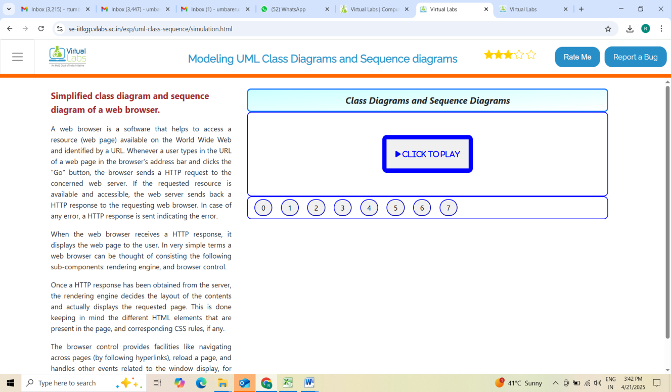

**B. Availability of work related to Innovation by Faculty in Teaching and Learning  is on Institute website.**

**<https://www.jspmrscoe.edu.in/information-technology/innovation-practices>**

1. **Availability of work for peer review and critique.**

**[https://github.com/jspmIt/R](https://github.com/jspmIt/JDM)TU**

**D: Reproducibility and Reusability by other scholars for further development**

**Views**, **likes**, **comments**, and **shares: P**eople are engaging with and potentially applying the content.

Students are forwarding these contents to other for watching

Students are giving Comments

Viewers are thinking critically and considering extensions

|  |  |  |  |
| --- | --- | --- | --- |
| **Sr.No** | **Innovation Used by** | **Details of User** | **Purpose  of**  **Reproducibility and Reusability** |
| 1. | Virtual Lab | Prof. Rupali T. Mahajan | To allow viewers to **repeat the process or concept** shown in the video and obtain the same results.  To. Encourage knowledge sharing and collaboration. |

**Course Co-ordinator                                                  HOD**

Prof. Rupali Umbare                                    Dr. Nihar M. Ranjan